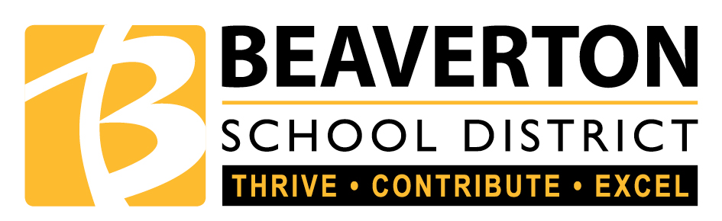

Hiteon Elementary School
Language Policy

Philosophy
Exposure and experience to language and all its richness and diversity opens doors to key questions about life and learning. And encourages students to develop responsible attitudes and find appropriate ways to take action in order to make a difference in the world.
~International Baccalaureate Organization 2007

We believe oral, written, and visual language permeates the whole curriculum. Language is the medium through which all curriculum is taught and learned. It facilitates communication and incorporates the skills of reading. writing, speaking, listening, and media literacy. There is a reciprocal relationship between using inquiry to facilitate language and using language to facilitate inquiry All teachers in the school are language teachers. Teachers instruct through inquiry and the best practices aligned in the English Language Arts Best Practices document by the Beaverton School District.

All students are provided a safe, nurturing, language rich environment that supports learning as well as social, emotional development and well-being. Our school community benefits from access to different cultures, perspectives and languages which increase cultural awareness and international-mindedness. We value and encourage students to respect the language, literature, and culture of their home country. We strive to create a caring language community in which all students feel accepted and supported, thereby feeling confident to be risk-takers.

School Profile

English is the mother tongue of most of the students at Hiteon. Spanish is the next most frequently used language of the population. Students come to school with varied ranges of language development and fluency. Some students have limited background knowledge and many children have not had preschool experiences. Approximately 32 percent of Hiteon students qualify for free and reduced lunch and participate in the breakfast and lunch programs offered at the school. Hiteon has some families that move frequently. The transition rates have increased in the past five years as the school district attendance boundary has shifted to include more dwelling complexes in our neighborhood school. The profile of the families offers opportunities for staff to provide differentiated instruction in all areas of language and to explore solutions to language related issues.

Language of Instruction

English is Hiteon’s language of instruction. It is the connection language across the curriculum. Reading, writing, speaking, listening, viewing and presenting are emphasized daily. Teachers structure teaching and learning situations to include inquiry and to provide for learning success. Language is taught through engaging, relevant units of inquiry and the essential elements of the Primary Years Programme: concepts, skills, attitudes, and action. The program of inquiry provides a framework for students to develop and use language. The library/media center at Hiteon provides opportunities for students to use technology and print resources to reinforce, support and extend classroom work. In addition to technology in the media center, Hiteon supports two technology labs and access to technology in the classroom.
Student growth with the language of instruction is documented as a body of evidence that is collected and reported as outlined in Hiteon’s Assessment Policy. A supportive language environment involves students’ learning to listen and use language, understand how language works, and use language as a tool to think about or reflect on a concept.

The disciplines of science and math require and understanding that there is language unique to these areas. Teachers and students understand that science and math require a comprehension of how these languages are expressed, what is being expressed and to understand the ability to fluently express thoughts and processes. We believe that mathematics and science are languages used to describe the real world, abstract concepts and solve real world problems. The school community also learns to recognize that disciplines such as art, music, and technology have vocabulary and language unique to each discipline.

Mother-tongue Support

Support for English, the language of instruction, is provided through differentiated instruction provided by all staff. Differentiated language instruction is supported through flexible grouping, work with teaching assistants, and resources such as Response to Intervention, Special Education and English Language Development. Hiteon also has dependable community volunteers who work to support students with all oral, written, and visual communication particularly in the primary grades. Writing across the curriculum is currently a main focus. Student progress in language is monitored, recorded, and reported as outlined in Hiteon’s Language Policy.

World Language

Currently, the world language of instruction at Hiteon is Chinese. Students receive forty-five minutes of Chinese language and culture instruction every six days. The world language instruction begins in kindergarten and is taught through fifth grade. The children expand their thinking about a culture that is beyond their experiences in the United States, creating global awareness through studying Chinese. The students experience language instruction through story telling, art, video, oral practice and games. It is understood that reinforcing, supporting and extending classroom work is an important role for the additional language teacher. The highly engaging course of study captures the spirit of becoming internationally minded.

This policy was developed and revised by the teaching staff at Hiteon Elementary.

Drafted 2014
Revised and approved 2015
Next review and revision 12/2016

